**Conversion Rate for Group Deals**

The **Conversion Rate for Group Deals** measures the percentage of group deals that lead to at least one successfully completed group. This KPI evaluates the effectiveness of group deals in achieving their intended purpose—encouraging group participation and resulting in successful group outcomes.

**Formula**

Conversion Rate (%)=Number of Completed GroupsTotal Group Deals Created×100\text{Conversion Rate (\%)} = \frac{\text{Number of Completed Groups}}{\text{Total Group Deals Created}} \times 100

**SQL Query**

SELECT

(COUNT(DISTINCT g.id) * 100.0 / NULLIF(COUNT(DISTINCT gd.id), 0)) AS conversion_rate

FROM

public.group_deals gd

LEFT JOIN

public.groups g ON g.group_deals_id = gd.id

WHERE

g.status = 'COMPLETED'; -- Ensure only completed groups are counted

**Importance of the KPI**

* **Measures Deal Effectiveness**: Helps assess how many group deals succeed in forming at least one completed group.
* **Improves Strategy**: Provides insights into whether group deals are designed effectively to attract and convert participants.
* **Customer Behavior Insights**: Indicates the level of interest and commitment customers have towards group deals.
* A **high conversion rate** indicates that group deals are successful in encouraging participation and resulting in completed groups.
* A **low conversion rate** suggests that group deals may need to be re-evaluated to improve their appeal or structure.

**Potential Actions Based on Insights**

* If the conversion rate is **high**:
  + Expand the use of group deals, as they are achieving their goals.
  + Consider increasing marketing efforts around group deals.
* If the conversion rate is **low**:
  + Reassess the structure, pricing, or incentives of group deals.
  + Analyze customer feedback to understand barriers to participation or completion.
  + Experiment with different deal terms to identify improvements.

**Visualization**

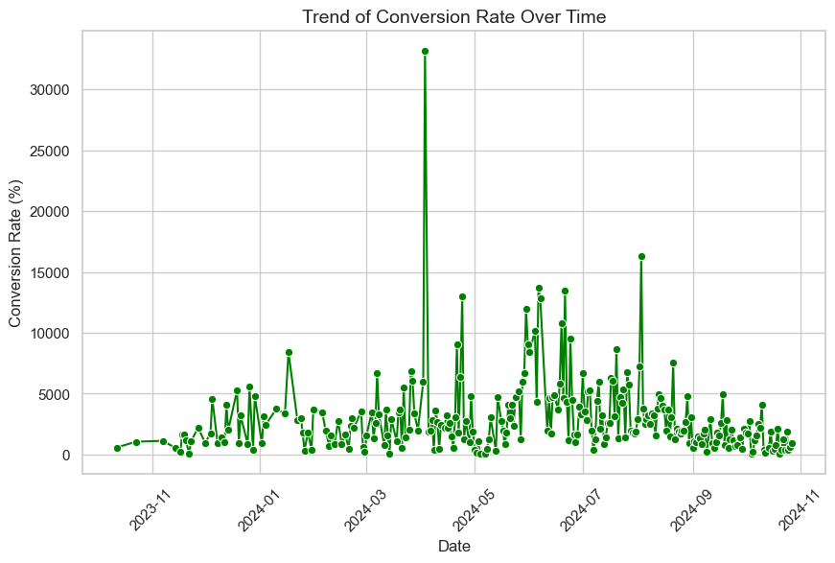

The Above chart displays the conversion rate as a percentage over a specified time period from November 2023 to November 2024. Here are some key observations:

**Key Observations**

1. **Fluctuations**:
   * The conversion rate shows significant fluctuations throughout the year, with many peaks and troughs.
2. **Spike in March 2024**:
   * There is a notable spike in the conversion rate in March 2024, reaching an exceptionally high value (over 30,000). This could indicate a specific event or campaign that drove increased conversions during this period.
3. **General Trend**:
   * After the spike in March, the conversion rate appears to stabilize but remains variable, with several smaller peaks and valleys.
4. **Lower Values**:
   * The majority of the data points are clustered at lower conversion rates, suggesting that while there are occasional high-performance periods, most of the time, the conversion rates are relatively modest.
5. **Volatility**:
   * The presence of many points with varying values indicates a volatile trend, which could be influenced by numerous factors, including marketing efforts, seasonal changes, or external events.

The data suggests that while there are instances of high conversion rates, the overall trend shows variability, with the majority of rates being lower. Further investigation into the causes of the March spike and the reasons behind the fluctuations could provide valuable insights for improving overall conversion performance.

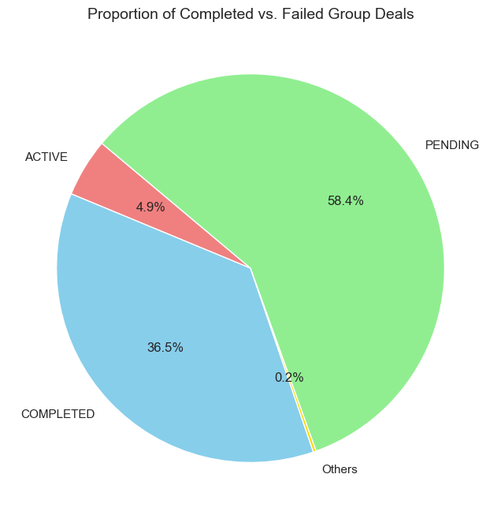

The Above pie chart displays the breakdown of different deal statuses in a visual format. Here are the key observations:

**Key Observations:**

1. **Majority Status**:
   * The largest segment is labeled "PENDING," accounting for **58.4%** of the total deals. This indicates that a significant portion of the deals is still in progress.
2. **Completed Deals**:
   * The "COMPLETED" segment represents **36.5%** of the total, suggesting that a good number of deals have been successfully finalized.
3. **Active Deals**:
   * The "ACTIVE" segment, at **4.9%**, indicates that there are relatively few deals currently active compared to the other statuses.
4. **Others Category**:
   * The "Others" category is quite small, comprising only **0.2%**. This suggests that any deal statuses not explicitly listed (such as 'FAILED') are minimal in number.

The chart indicates that the majority of deals are either pending or completed, with very few active or failed. This could reflect a healthy pipeline of deals in progress. However, the small percentage of active and failed deals might warrant further investigation to understand if there are underlying issues affecting these statuses. Overall, the data suggests a strong focus on pending and completed transactions, which could be positive for business operations.